**How to use the LC-MISDK in Labview**

(About the import .NET Class Library)



Copyright ⓒ 2016 KONICA MINOLTA,INC.

**●Note this manual abbreciates product names as follows**

|  |  |
| --- | --- |
| Name Given inThis Manual | Official Name |
| Windows 7 | MicrosoftⓇ WindowsⓇ 7 Business Operating System |

**●Trademark Notices**

Microsoft and Windows are registered trademarks of the Microsoft Corporation, in the US and in other countries.

Other company names and product names that appear within this manual are trademarks or trademarked of their respective companies.

**●Notes of this Manual**

Copy or reproduction of all or any part of the contents of this manual without Konica Minolta’s permission is strictly prohibited.

The contents of this manual are subjects to change without prior notice.

Konica Minolta will not accept any responsibility for consequences arising from the use of the software.

**Contents**

Introduction 4

1.　System Environment 4

2.　How to the LS-MISDK 5

2.1　Generate instance 5

2.2　How to use the method 7

# Introduction

This manual describes how to use the LC-MISDK in Labview.

# 1.　System Environment

When you execute vi, please copy 50 dll in the LC-MISDK_LabVIEW folder and calccolor folder and IDMap folder to the same folder as [LabVIEW.exe] (C:\Program Files (x86)\National Instruments\LabVIEW 2015). When you execute exe, please copy it to the same folder as exe which you made.

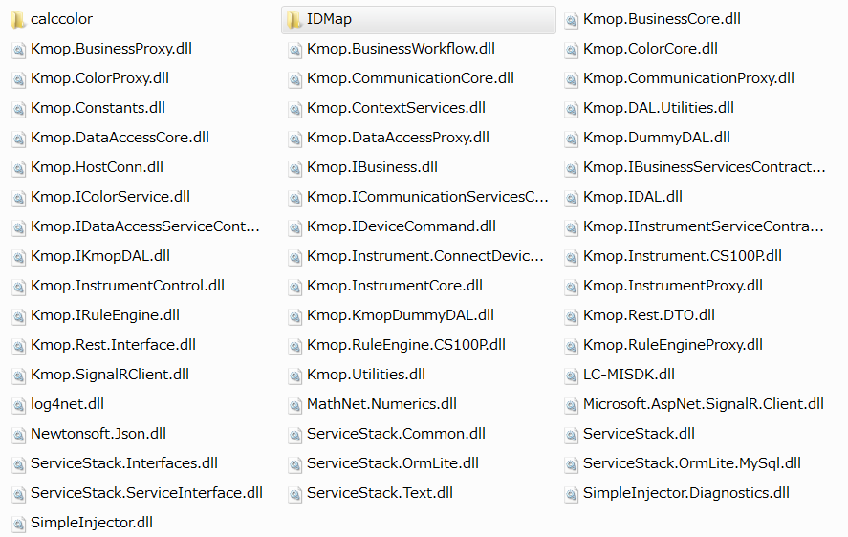

# 2.　How to use the LS-MISDK

## 2.1　Generate instance

LC-MISDK is made by Singleton pattern. Therefore it cannot generate instance of SDK using a constructer node. This chapter mentions about method of the instance generation of the Singleton pattern class.

Select the [connectivity] → [.NET] → [Invoke Node] in a function dialogue, and place it in the block diagram.

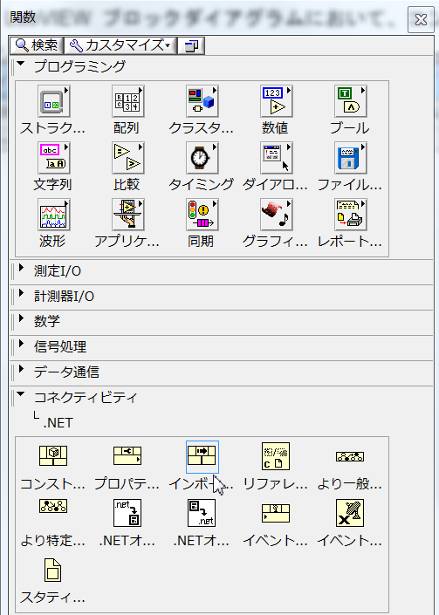

Right-click of the [Invoke Node], and select [Select the class]→ [.NET] → [reference].

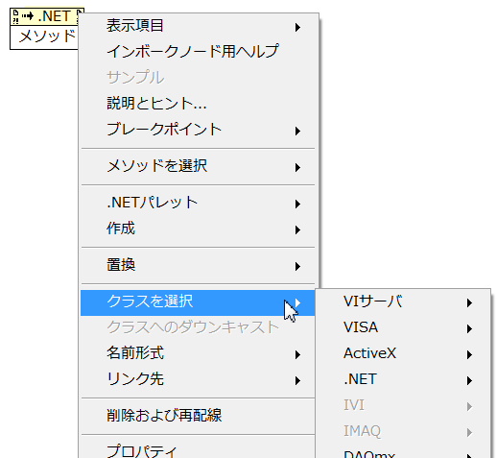

Select the LC-MISDK.dll to an assembly and the LightColorMISDK to an object, then press the OK. (Please confirm [1.System Environment] about the directory of LC-MISDK.dll.)

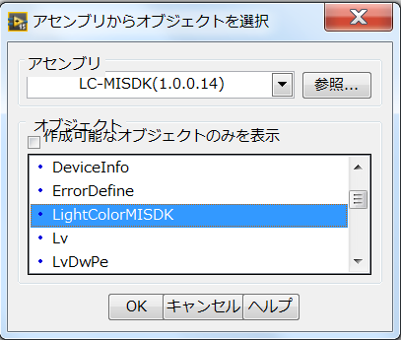

Select the [GetInstance] in method.



Right-click of the [Invoke Node] again, select the[creation] → [invariable].

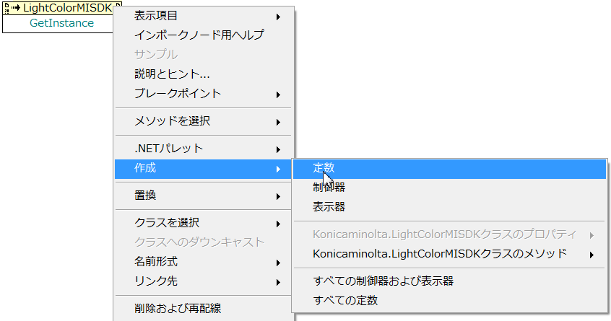

The icon of [.NET] is created, and connect it to [Invoke Node].

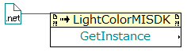

## 2.2　How to use the method

Connect the output of [GetInstance] to the instance of the Invoke Node of LightColorMISDK.

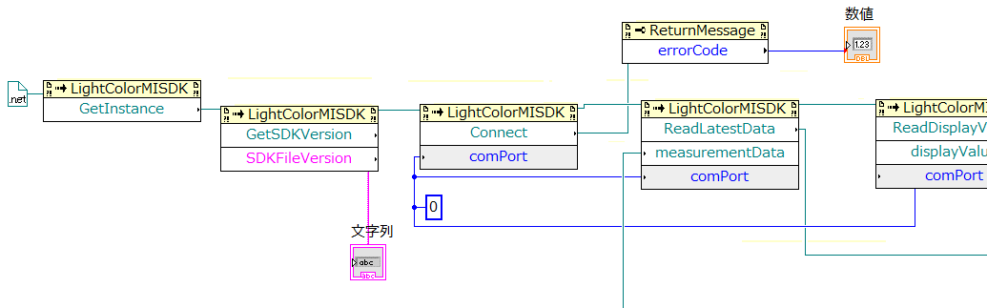

Please refer to [LC-MISDK_SimpleInjector.ActivationException.vi] about the measurement.

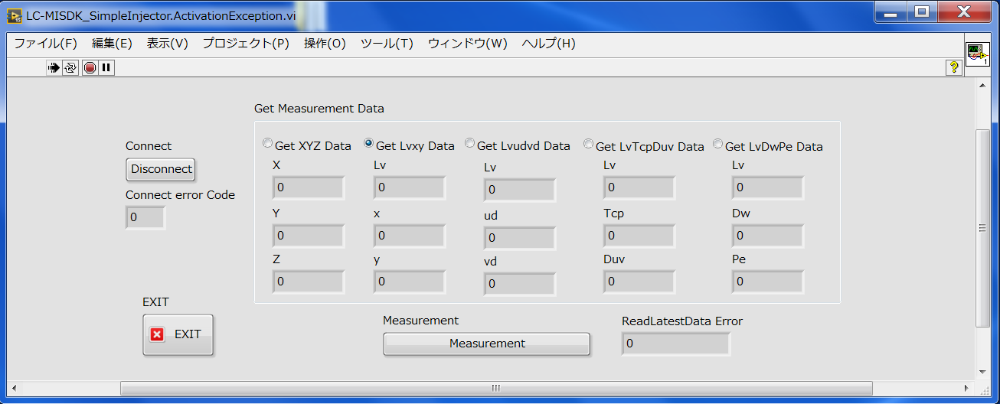

Please refer to [[LC-MISDK_SetMeasurementCondition.vi] about the various settings.

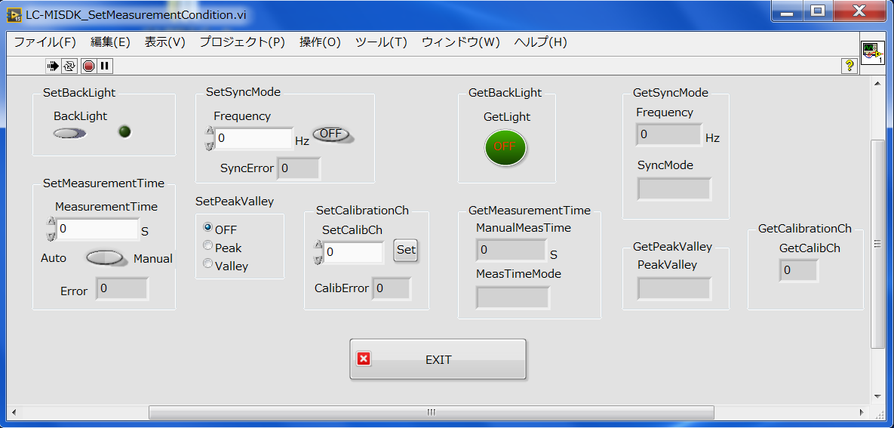

When you use other API, please refer to [LC-MISDK_ReferenceManual_ENG.pdf].

Concluded.